https://www.build-business-websites.co.uk/jenkins-behind-apache-proxy/comment-page-1/

before

http://dms-build.westus.cloudapp.azure.com/jenkins-on-azure/?from=%2F

1. install apache

We want to configure Apache as a proxy for HTTP traffic **to** and **from** Jenkins. These commands will enable the modules that do the actual routing.

sudo a2enmod proxy

sudo a2enmod proxy_http

Expect the response to resemble

Enabling module proxy.

To activate the new configuration, you need to run:

service [apache2](https://www.build-business-websites.co.uk/apache2-web-server/) restart

2. go to sites-available and edit the 000-default.conf

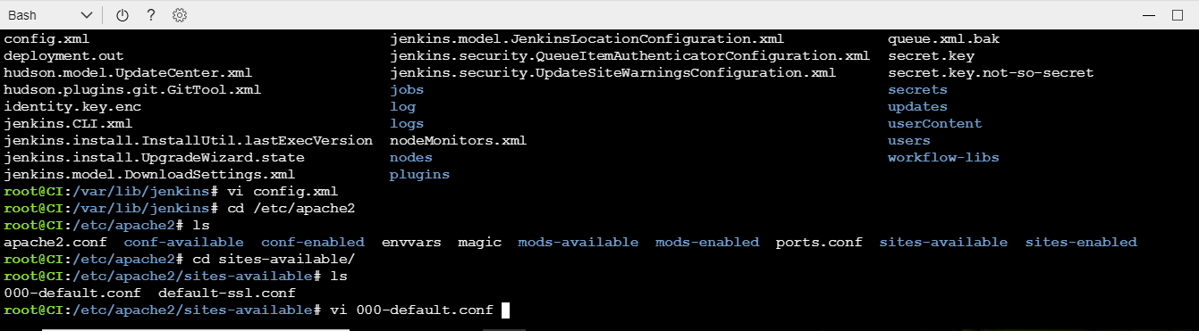

3. behind virtual host paste the config

ProxyPass /jenkins http://localhost:8080/jenkins nocanon

ProxyPassReverse /jenkins http://localhost:8080/jenkins

ProxyRequests Off

AllowEncodedSlashes NoDecode

<Proxy http://localhost:8080/jenkins*>

Order deny,allow

Allow from all

</Proxy>

4. now login to jenkins in ubuntu using /etc/default/jenkins

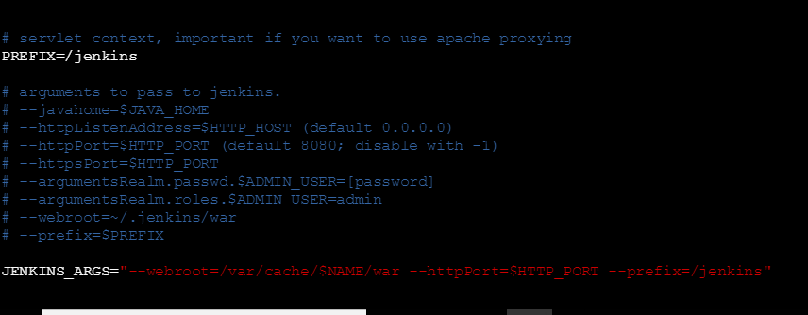

prefix and jenkins args are important

5. restart

6. Adding users in jenkins in

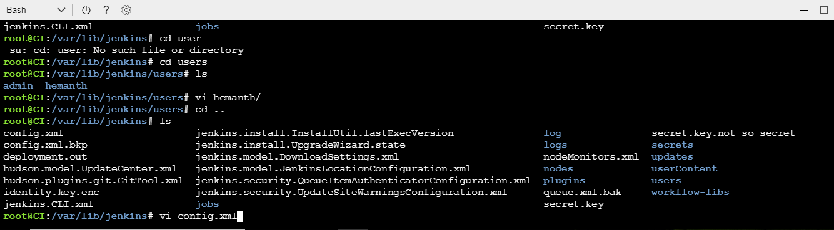

7. in config.xml keep false security signup

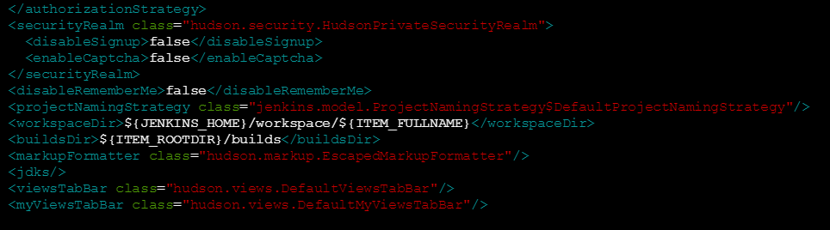

now what happens is you can able to login or create a new account

now if you keep true in signup you cannot create a new account

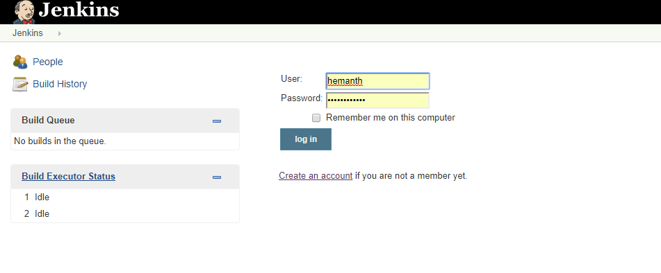

you can see the users created in this path

